Library and files management using PnP Powershell

First, you will have to connect to your SharePoint Online Site using the following command.

*Connect-PnPOnline -Url https://<Your-tenant-name>.sharepoint.com/sites/<your-site-name>*

**Add-PnPFile**

The *Add-PnPFile* command is used to upload the document file to the SharePoint library.

**Example 1**

This example uploads the local file specified in the Local FilePath to the Shared Documents folder.

*Add-PnPFile -Path "D:\NewFiles\PnPPowershell.docx" -Folder "Shared Documents"*

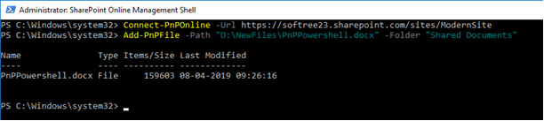

**Output**

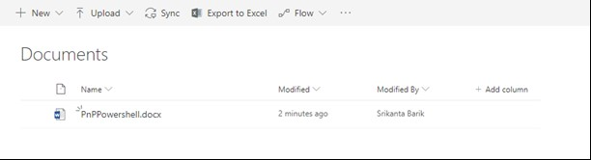

**Example 2**

This example uploads the local file specified in the Local FilePath to the Shared Documents folder with a different name.

*Add-PnPFile -Path "D:\NewFiles\PnPPowershell.docx" -Folder "Shared Documents" -NewFileName "NewPnPPowershell.docx"*

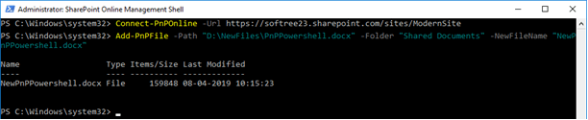

**Output**

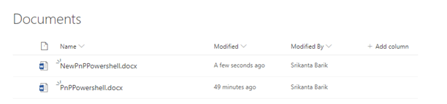

**Example 3**

This example uploads the file PnPPowershell.docx to the Shared Documents folder. After uploading, it will set the modified date to 1/5/2019.

*Add-PnPFile -Path "D:\NewFiles\PnPPowershell.docx" -Folder "Shared Documents" -Values @{Modified="1/5/2019"}*

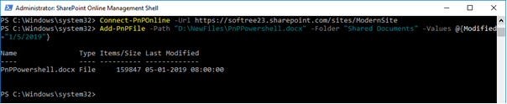

**Copy-PnPFile**

The *Copy-PnPFile*command is used to copy a file or folder to a different location.

**Example 1**

This example copies a file named PnPPowershell.docx located in a document library called NewDoc to a new document named NewPnPPowershell.docx in the same library.

*Copy-PnPFile -SourceUrl NewDoc/PnPPowershell.docx -TargetUrl NewDoc/NewPnPPowershell.docx*

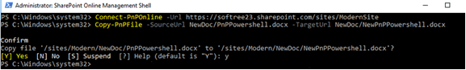

**Output**

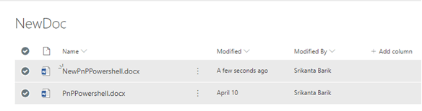

**Example 2**

This example copies a file named PnPPowershell.docx located in a document library called NewDoc in the current site to another site collection ModernSite.

*Copy-PnPFile -SourceUrl NewDoc/PnPPowershell.docx -TargetUrl /sites/ModernSite/Doc/PnPPowershell.docx*

Add and Manage SharePoint Files Using PnP PowerShell

**Note**If a file named PnPPowershell.docx already exists, it won't perform the copy operation.

**Output**

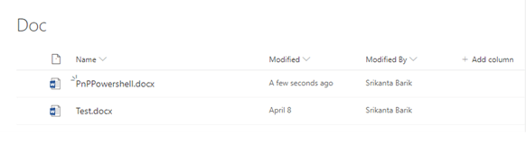

**Find-PnPFile**

The *Find-PnPFile* command is used to find a file in the file system of the web.

**Example 1**

*Find-PnPFile -List "Documents" -Match *.docx*

This example returns all the .docx files located in a given library.

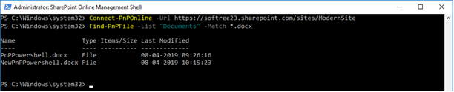

**Example 2**

*Find-PnPFile -Folder "Shared Documents/SubFolder" -Match *.pdf*

This example returns all the .docx files located in the given folder.

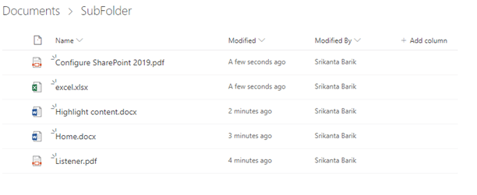

**Output**

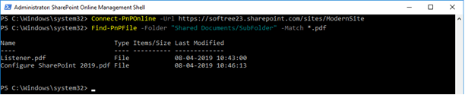

**Example 3**

*Find-PnPFile -Match *.docx*

This example returns all the .docx files located in the current web.

**Output**

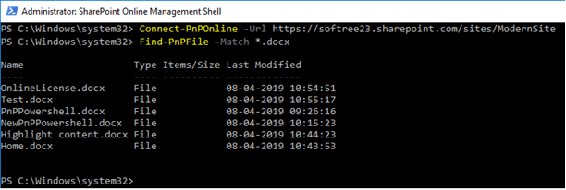

**Get-PnPFile**

The *Get-PnPFile* command is used to download a file.

**Example 1**

*Get-PnPFile -Url /sites/ModernSite/Doc/OnlineLicense.docx*

This example retrieves the file and downloads it to the current folder.

**Output**

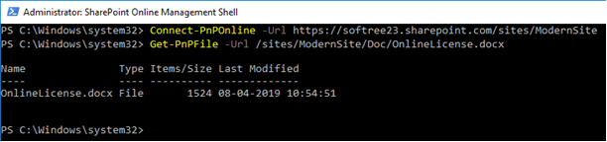

**Example 2**

*Get-PnPFile -Url /sites/ModernSite/Doc/OnlineLicense.docx -Path D:\NewFiles -FileName OnlineLicense.docx -AsFile*

This example retrieves the file and downloads it to D:\NewFiles.

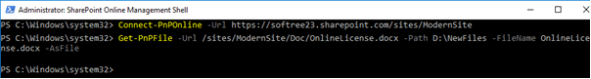

**Output**

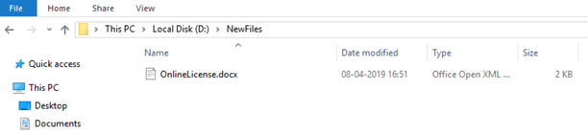

**Remove-PnPFile**

The*Remove-PnPFile* command is used to remove a file from the SharePoint library.

**Example 1**

*Remove-PnPFile -SiteRelativeUrl Doc/PnPPowershell.docx*

This example removes the file PnPPowershell.docx from the "Doc" document library.

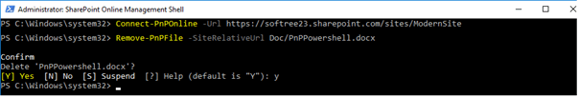

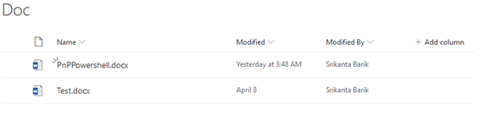

**Output**

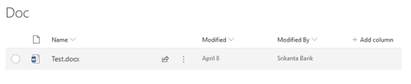

**Example 2**

*Remove-PnPFile -SiteRelativeUrl Doc/OnlineLicense.docx -Recycle*

This example removes the file PnPPowershell.docx from the "Doc" document library and saves it to the Recycle Bin.

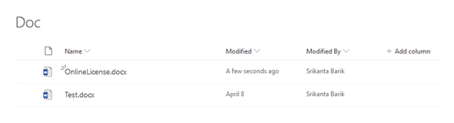

**Output**

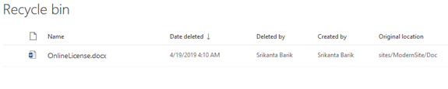

**Rename-PnPFile**

The*Rename-PnPFile* command is used to rename a file in its current location.

**Example 1**

In this example, the command renames a file named PnPPowershell.docx located in the document library called Doc located in the site collection to NewPnPPowershell.docx.

*Rename-PnPFile -ServerRelativeUrl /sites/ModernSite/Doc/PnPPowershell.docx -TargetFileName NewPnPPowershell.docx*

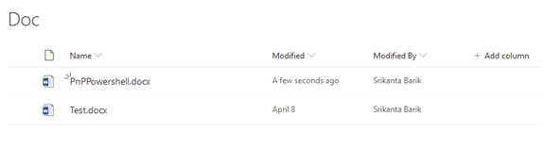

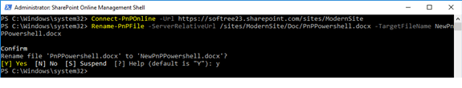

**Note**If a file named NewPnPPowershell.aspx already exists, it won't perform the rename action.

**Output**

